Lawnmower RC Car Prototype

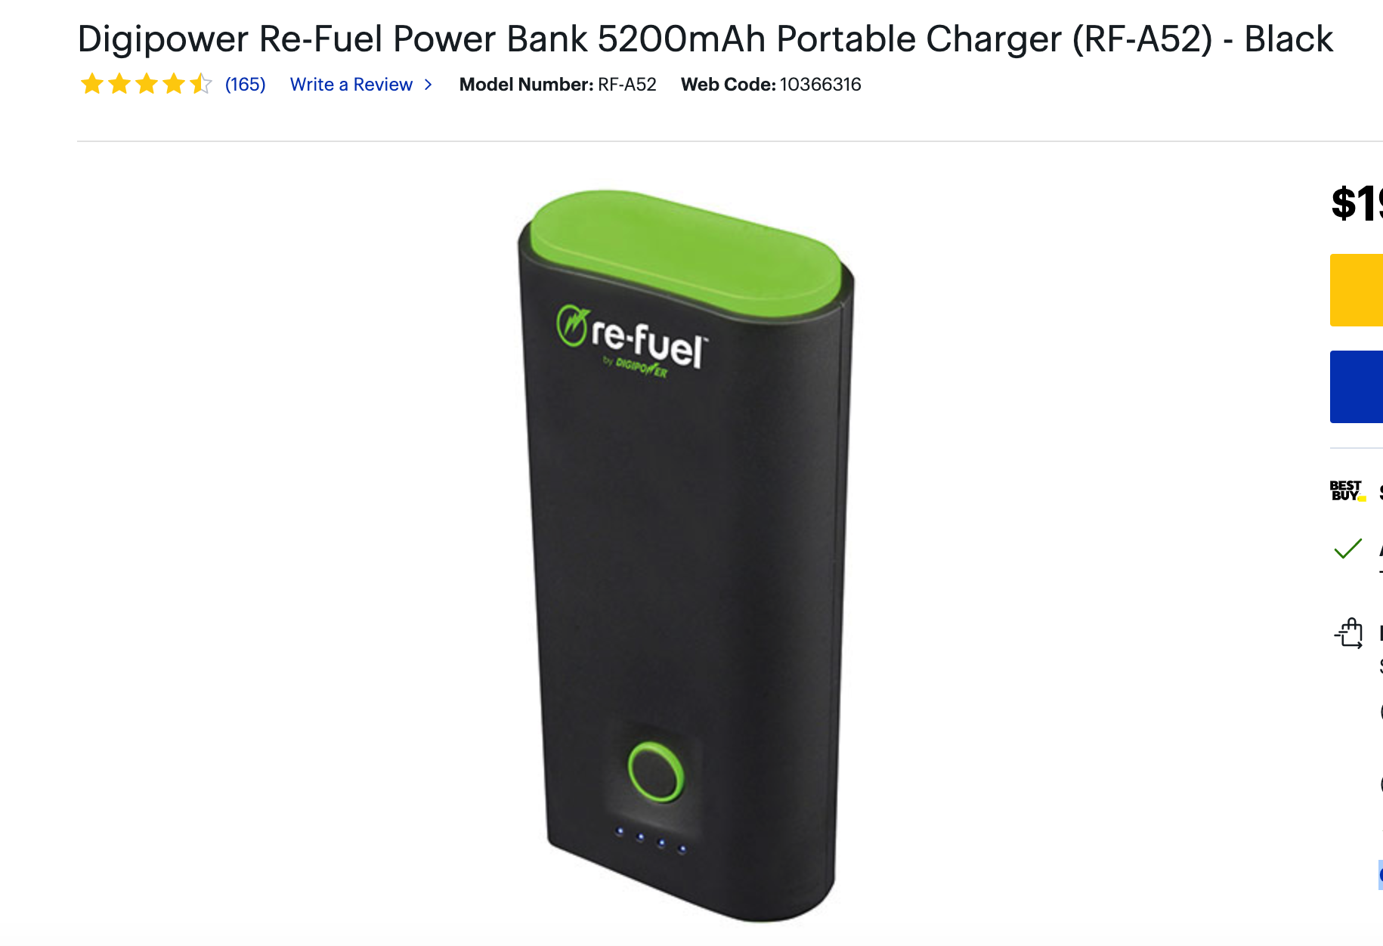

**8cm**

[ivinkenv@uwo.ca](mailto:ivinkenv@uwo.ca)

3d printing services

* $20 cubic inch
* Can print holes in the body after printing
* Make sure the design prototype has STL file format
* Can be done in solid works or autocad

**Saturday 12pm-5:30pm**

* Meet Middlesex parking lot, go to home depot get
  + sheet of plastic for car basis
  + screws for wheels
  + super glue for plastic
* go to best buy get power bank above